**Lab manual 7&8!**

**Repetition Statement (for loop, nested for loop)**

**Task 1**:

Write a C++ program to print a multiplication table of any number using a for loop.

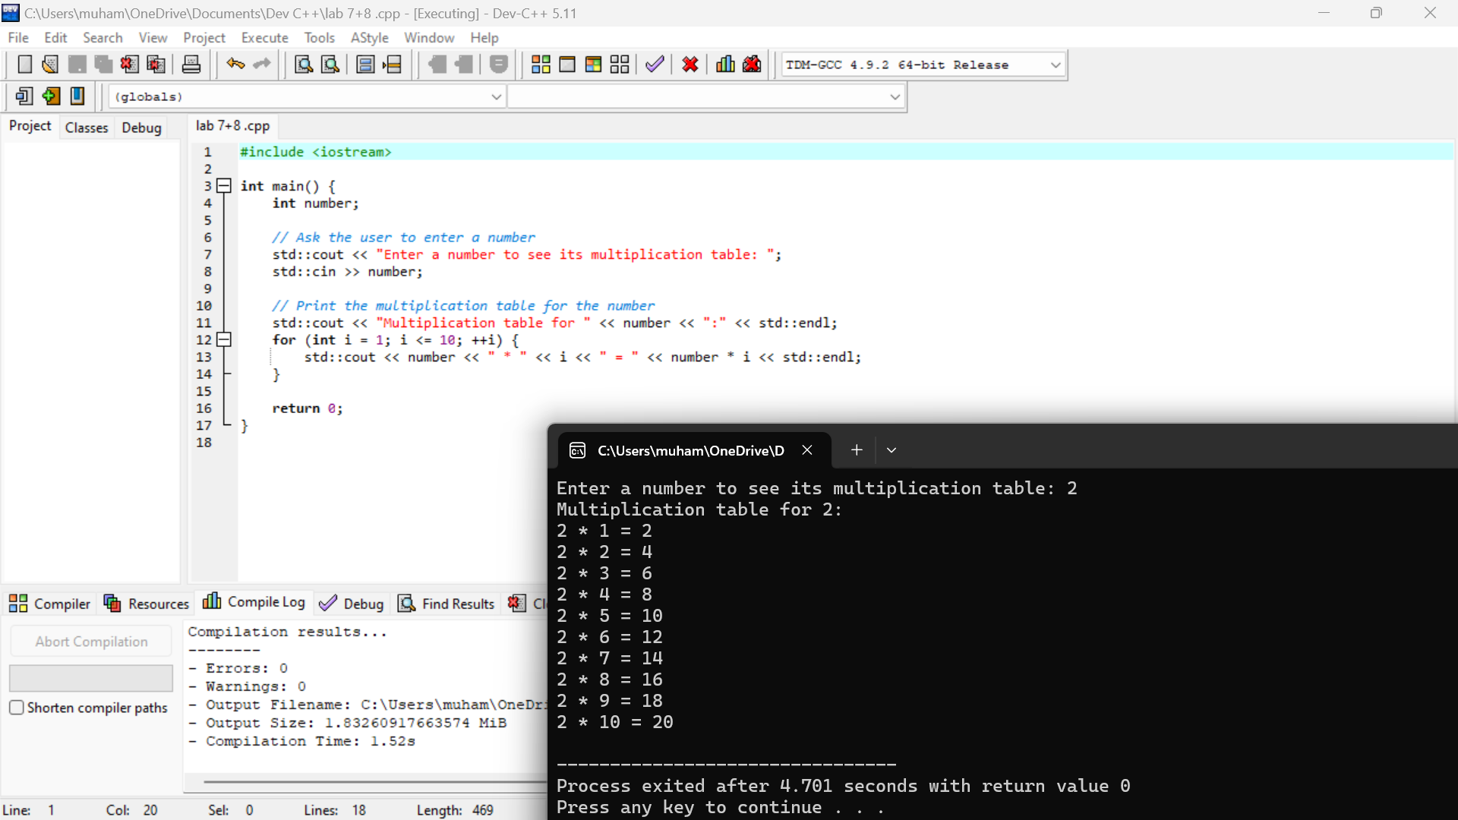

**Task 2:**

Write a C ++ program to input a number and calculate its factorial using a for loop.

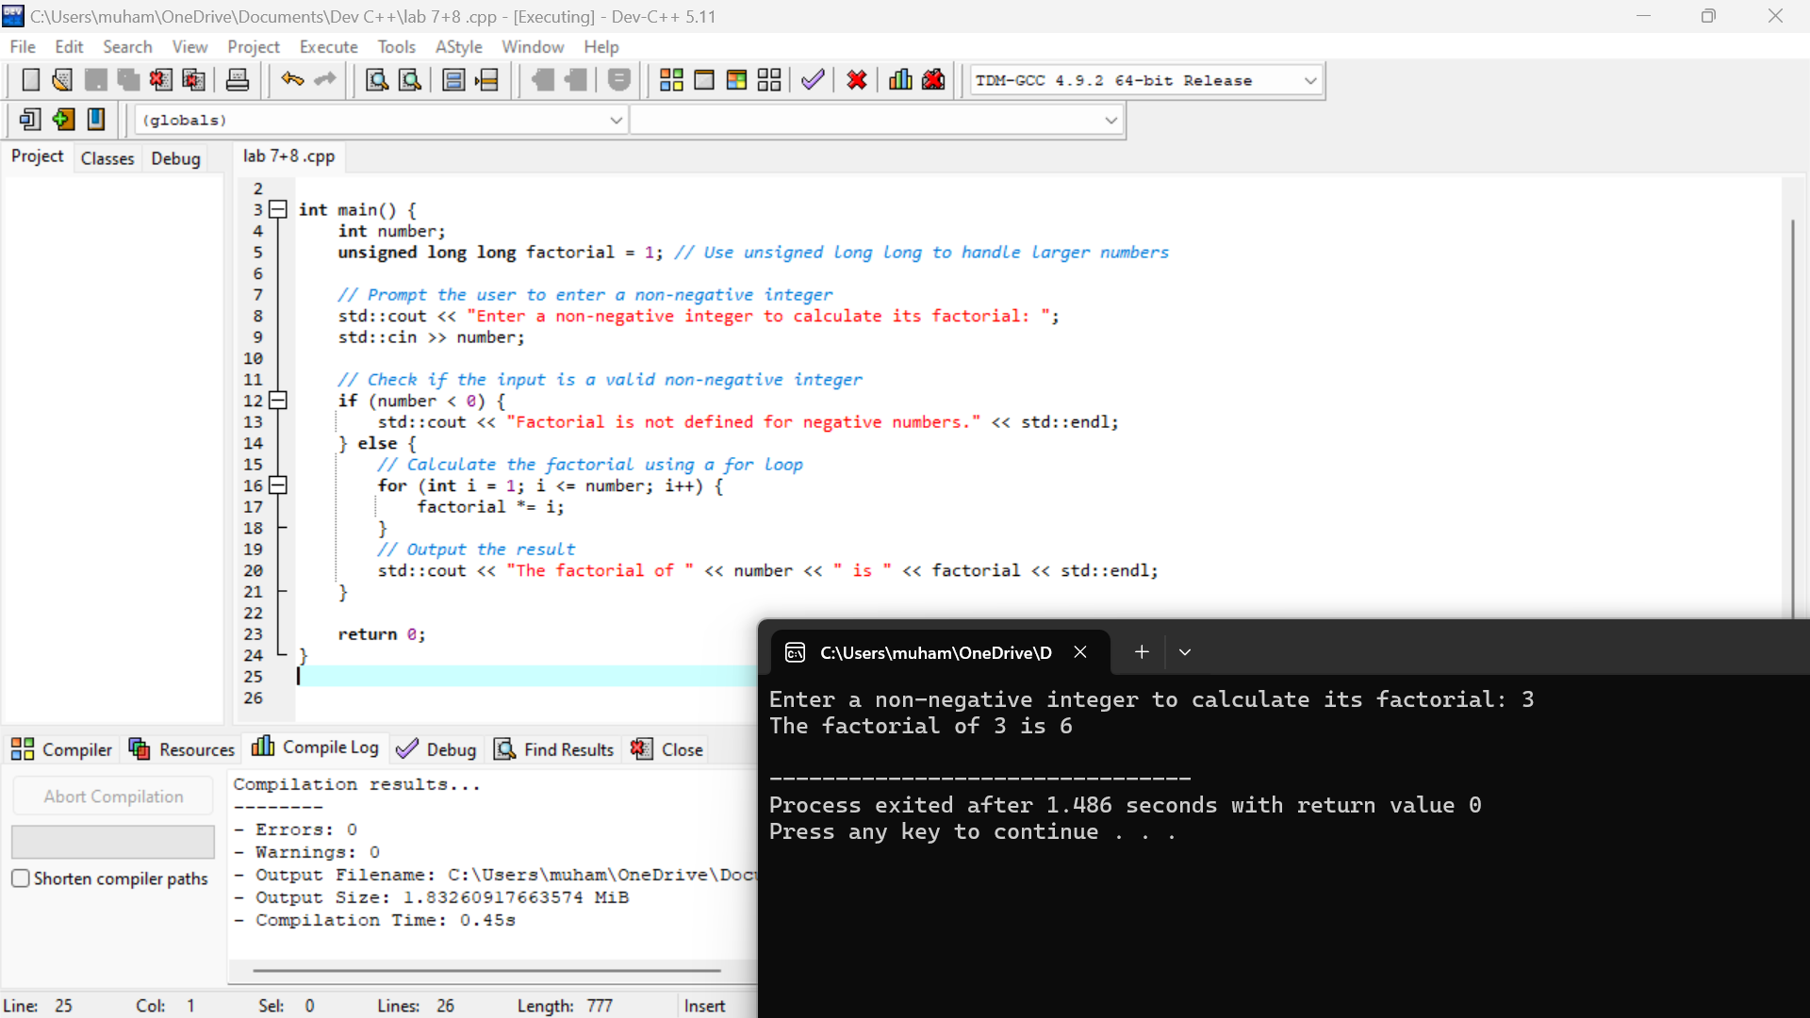

**Task 3:**

Write a C++ program to print the following patterns using nested for loop.

